1. You have opened a screen by right clicking on the name of the file (for example: Screen1.java), and selecting “GUI Builder” in the menu. We have a screen with labels, buttons, etc.

Level of difficulty:   
Estimated time: 10 mn

[**www.codapps.io**](http://www.codapps.io)by Clement Levallois **@codapps_io** [**www.coursera.org/learn/codapps**](http://www.coursera.org/learn/codapps)



**Module 3: Designing your app**

*How to place things where we want on a screen: layouts*

The screen is not organized : any label or button we have added is just placed in line, next to each other from left to right.

We can change that.

For example, we might want to have everything lined up vertically. Let’s do it. Click on the “tree” icon ( ), then select the screen (**red arrow**) :

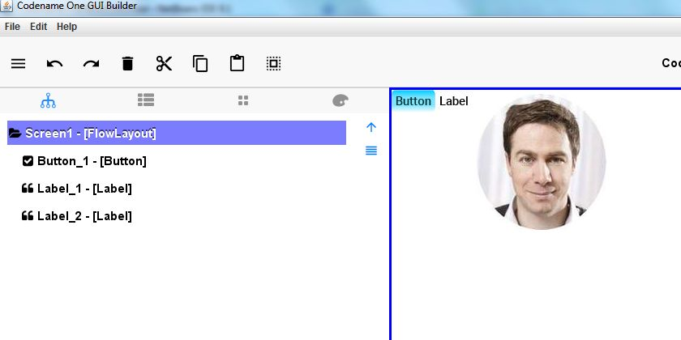

So we see in this example: a Button, followed by a Label, followed by a picture, on in one line from left to right. To change that, make sure Screen1 is selected (highlighted in purple) and click on the Layout Settings:

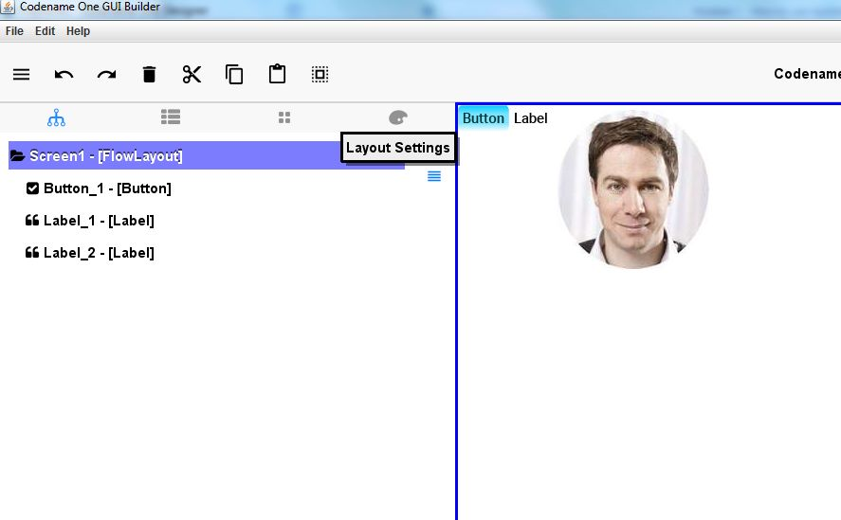

1. Now, you can select different layouts. I let you try the BorderLayout, the Grid Layout, the FlowLayout, the BoxLayout Y, the BoxLayout X, and see how things get composed differently on screen. Here is the BorderLayout X, were everything is in columns, taking all the vertical space:

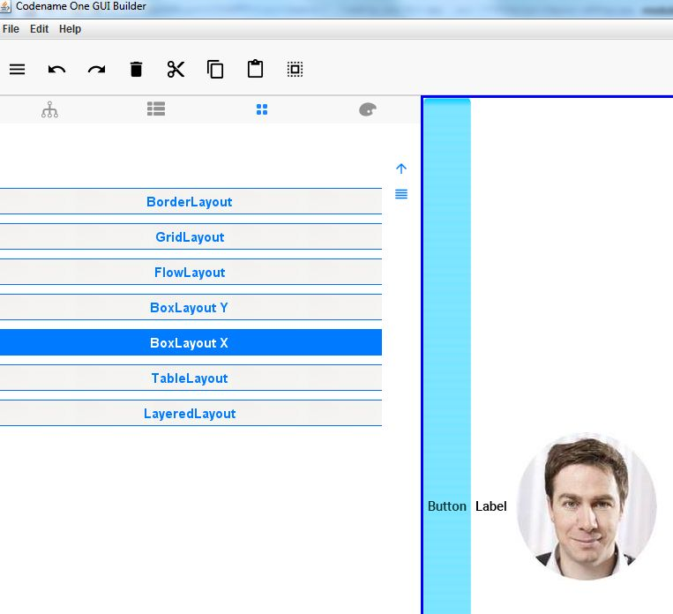

1. Go to the property tab and find the property « Layout » (**blue arrow** in the picture above). Click on « Flow Layout » on the right.

Level of difficulty:   
Estimated time: 10 mn



[**www.codapps.io**](http://www.codapps.io)by Clement Levallois **@codapps_io** [**www.coursera.org/learn/codapps**](http://www.coursera.org/learn/codapps)



**Module 3: Designing your app**

*How to place things where we want on a screen: layouts*

1. Some layouts can be adjusted with some parameters that you control. Take for example the “Grid Layout”, which divides the screen like a grid and puts Labels, Buttons, stuff… inside each cell of the grid. How many rows and columns should the grid have? You can decide it. Just select the GridLayout, then click on “Settings” at the bottom and change the values:

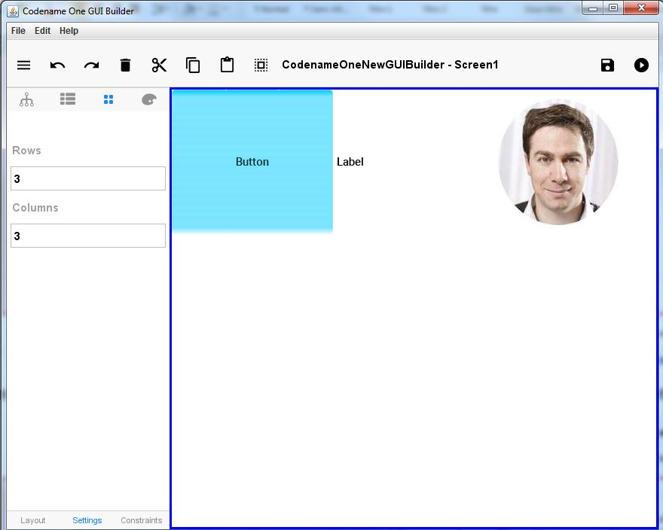

Level of difficulty:   
Estimated time: 10 mn

Here I created a 3 x 3 grid, with just the first row occupied. Since I haven’t created many labels or anything else, the two rows at the bottom have remained blank. But add Labels or else, and they will be placed in there.

1. So we have a way to change how the screen is organized. But this is not good enough: we would prefer to have some regions of the screen organized in one way (for example : vertically), and some other regions of the screen where things are placed in a different way (for example : in a grid).

[**www.codapps.io**](http://www.codapps.io)by Clement Levallois **@codapps_io** [**www.coursera.org/learn/codapps**](http://www.coursera.org/learn/codapps)



**Module 3: Designing your app**

*How to place things where we want on a screen: layouts*

How do we give different layouts to different regions of the screen?

The solution is:

* We put in a box the things we want to place in a certain way.
* We apply a layout (vertical, grid…) to this box.
* Other things that we want to organize in a different way: we put them in a different box, and we apply a different layout to this box. Simple!

The boxes that can contain Labels, Buttons, pictures, etc… and they can have a layout just for them. Boxes are called **Containers**. So we add containers to our screens, put stuff in them, and apply layouts to them.

Level of difficulty:   
Estimated time: 10 mn

1. Adding a Container :

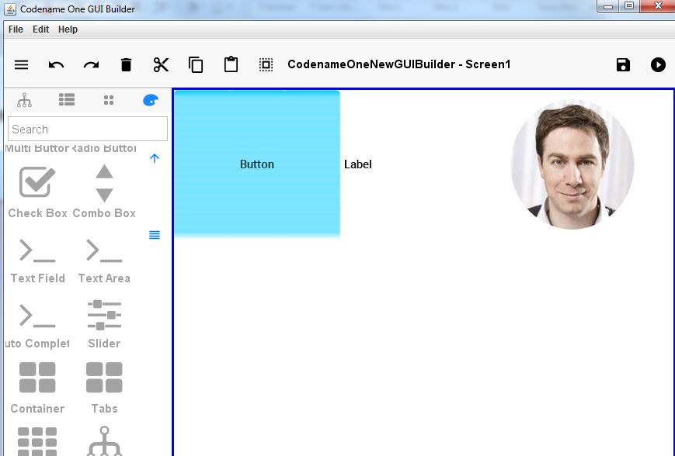

1. Click here

2. drag and drop the container on the screen

1. Move the container around on the screen. You’ll see that it is easy to put existing Components in it (Labels, Buttons, Images…), or to remove these things so to leave the Container empty. Click on the tree view ( ), to see that when a Label or something is inside the Container, they are nested inside it in the list; it appears slightly offset to the right. Here,I have moved by drag and drop the Label and the Button in the Container:

[**www.codapps.io**](http://www.codapps.io)by Clement Levallois **@codapps_io** [**www.coursera.org/learn/codapps**](http://www.coursera.org/learn/codapps)



**Module 3: Designing your app**

*How to place things where we want on a screen: layouts*

**KEEP YOUR HEAD COLD**: in my experience, things can disappear from the screen when we place them in the Container (where’s my Button???). You can always go to the tree view ( ) to see things as they really are. But this remains annoying to have a wrong view on screen. Save your file (File -> Save), close your screen and open it again in NetBeans: things should be back to normal.

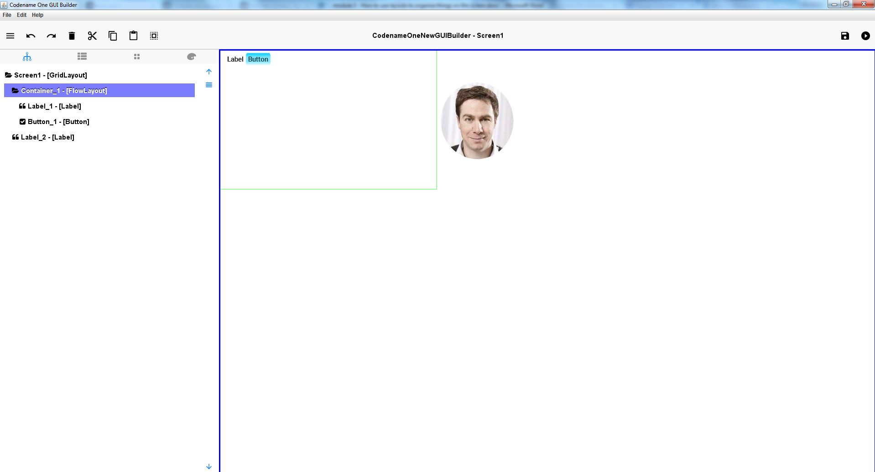

The container, we can see its borders in green. Inside it, the Label and the Button are in a Flow Layout: from left to right without anything particular. The rest of the screen remains organized in a 3 x 3 Grid Layout.

See that the Label and the Button appear slightly off on the right, showing that they are “inside” the container.

We can change the layout of the container, let’s put everything horizontally on top of each other inside the container: that’s a GridLayout Y. With the Container still selected (should be highlighted in purple in the Tree view, or borders in green on screen), we click on “Layout Settings”, then “BoxLayout Y”:

Level of difficulty:   
Estimated time: 10 mn

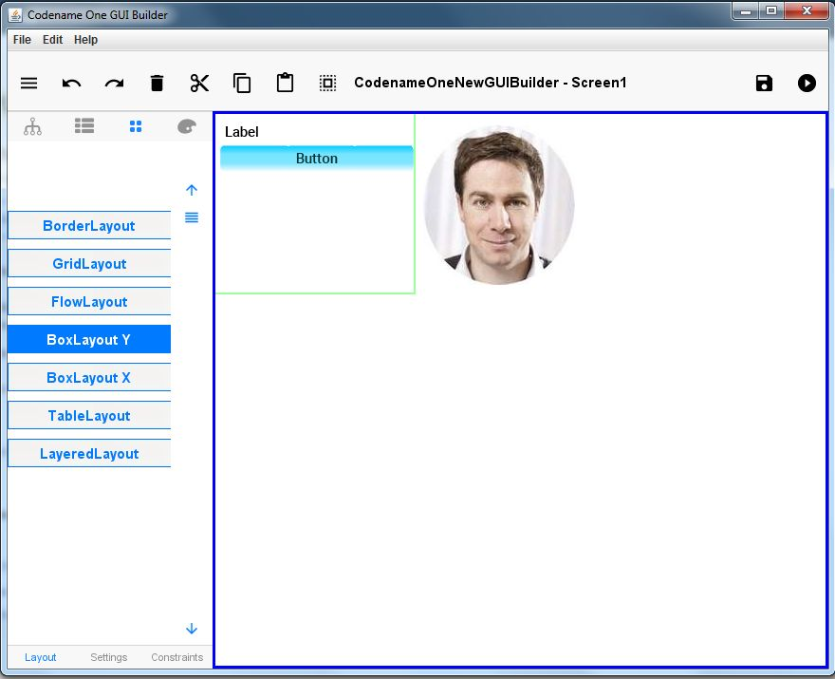

Now things are organized from top to bottom in the Container, because we changed the Layout of the container to “BorderLayout Y”.



[**www.codapps.io**](http://www.codapps.io)by Clement Levallois **@codapps_io** [**www.coursera.org/learn/codapps**](http://www.coursera.org/learn/codapps)



**Module 3: Designing your app**

*How to place things where we want on a screen: layouts*

That’s it!

Level of difficulty:   
Estimated time: 10 mn

Last things:



1. In the Tree view ( ), you can see the name of the layout which is currently applied to the screen, or this or that Container… great! Except that when you change the layout, it is not always updated in this view. The best it so save (File -> Save), close the screen and reopen it. Then you are sure that the layouts described in the Tree view are the correct ones.
2. Design is key! Now that you know how to arrange things precisely on the screens of your mobile app, go and design some screens! The best technique is probably to get inspiration from existing designs. You will find plenty of examples here:

<http://pttrns.com/>



[**www.codapps.io**](http://www.codapps.io)by Clement Levallois **@codapps_io** [**www.coursera.org/learn/codapps**](http://www.coursera.org/learn/codapps)



**Module 3: Designing your app**

*How to place things where we want on a screen: layouts*